EDRCC End of Year round up 2023

It seems 2023 has been a very windy year, but despite that we flew on 123 occasions on the strip bettering last year by 11 days. The best month was June with 18 flying days, the worst being March with only 4 days. Both January and February we had reasonable weather, and got out on 9 days in each month. Not bad…

Crashes

There has been a lot this year, top honours (again) must go to Josh, he has even ejected batteries whilst flying, the model, actually carried on flying and landed superbly. Some say even better…
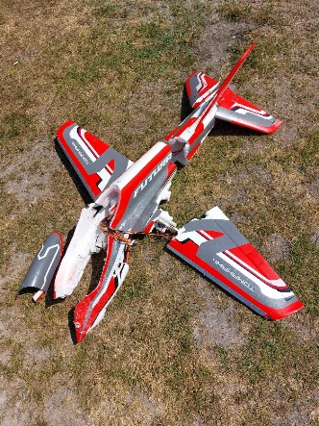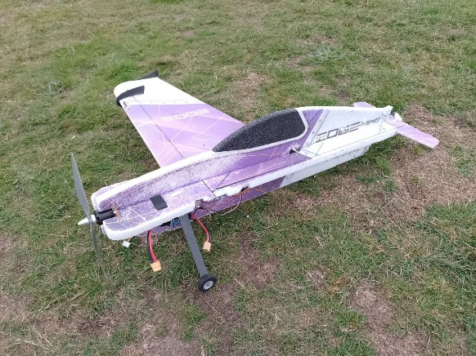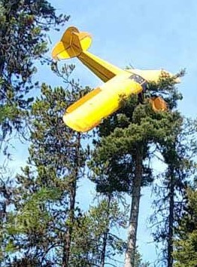
Josh’s crashes are mainly due to his incredible flying skills and the fact that he does push it…
Mike J has had a few this year also, he repairs them quick so you don’t tend to notice it…
There has been a few tree landings at Peak Hill, Roy and Mike O come to mind. maybe the pic on the right is a fake…

Achievement Scheme

Well done to the following for getting their “A” cert, John Wallinger, Roy Barber and Martyn Bright. All flew well to pass their flying tests. Mike got close, but had a panic attack when half way through it. The daft thing is he can do it easily.
Well done to Nigel for getting his “B” Certificate, He took it at the SW Achievement scheme open day run by the Okehampton club. Martin Brown was not quite so lucky…
We could do with another Examiner, that will then enable us to do “B” tests as well, any volunteers?

Most improved pilots…

Difficult this year, there are so many Pilots who are really getting good. So let’s start with the youngsters. Tom Gardner and Oscar have really come on.
Oscar is almost ready to fly solo. He just needs perhaps a little more discipline when flying circuits. Credit must go to Pete B for his training.
Steve’s boy Tom, is also getting it together under his dad’s careful training. He did a landing a few weeks ago which was superb. Well done both of you.

Mike Orme and Roy Barber are both making huge strides with their flying, Roy’s Inverted flying is very good, and although Mike is not into the aerobatic stuff quite yet, his general flying is a treat to watch.

Events.

BMFA Centenary Celebration Part 2.

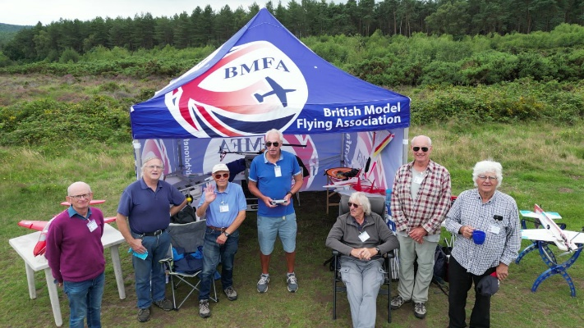
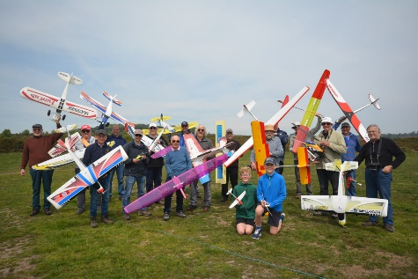
This again got underway in May, with a great effort, we even exceeded last years numbers airborne thanks to Steve’s two boys. Again, it was windy, but the mass landing seemed to go smoothly with no crashes or mid-air collisions.

Pebble bed Heaths.

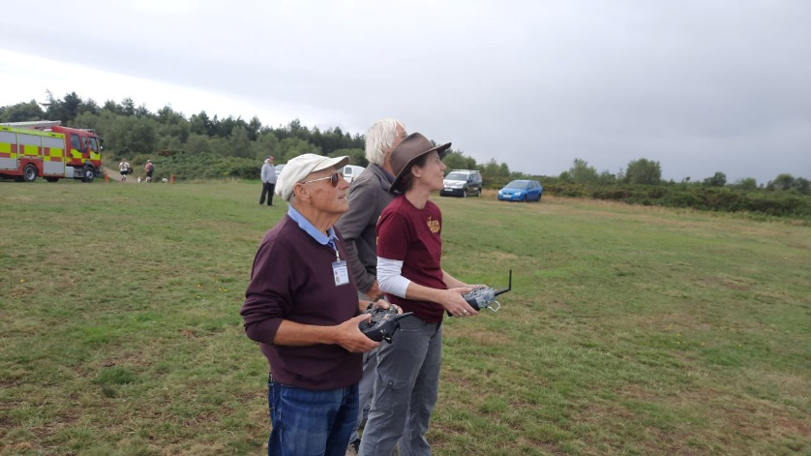
Clinton Devon Estates invited the EDRCC to support them with their display featuring Pebble bed Heaths.org, Devon Loves Dogs.co.uk and Devon Fire and Rescue. We were also asked to provide a static display of some of our members models. Josh even managed to put on a bit of a flying display, and under the guidance of Mike Jones we persuaded some of the CDE staff to have a go at flying. A great bit of PR for the club.

Concours De Elegance.

The overall winner was John Deeming with an immaculate Miss America from the sport category.
First place in the Scale category went to Pete Bavington with his superb Hurricane.
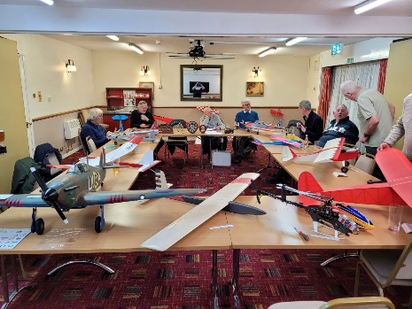
First place in Sport went to John Deeming with his Simple T Craft model.

Gliding.

The club really does have a strong gliding group withing the club. Main flying site for slope soaring is Peak Hill, but other sites have been flown this year like Hartridge and Salcombe Regis.
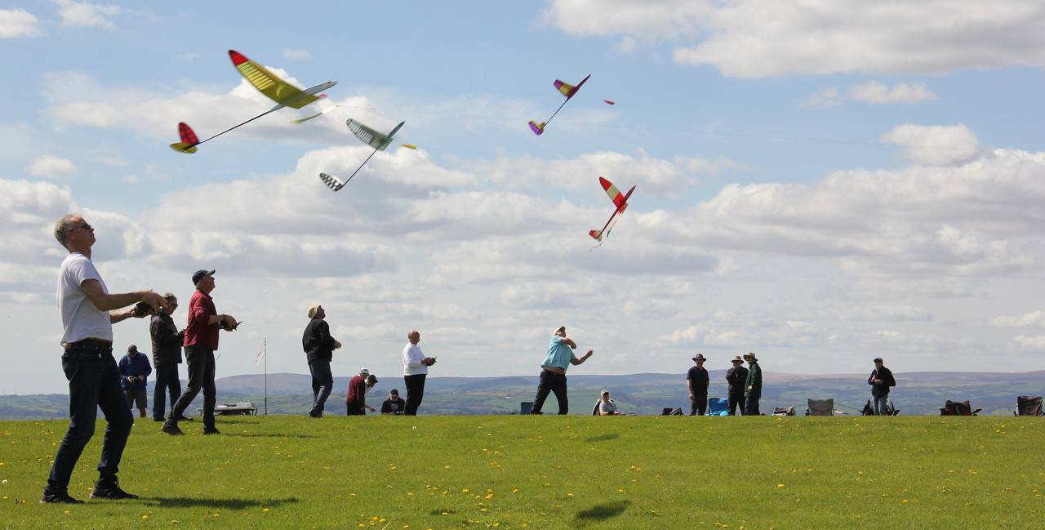
The start of this year’s SW Gliding comps went very well, with Torbay and Castor events held in near perfect conditions. The EDRCC members were doing well, with Mark RH in the lead after the two rounds, however, the weather became pants with the remainder of events rained off. It was then decided to abandoned the comp for this year. Next year I think we will see an even larger group of pilots taking place from our club.

Lidl Gliders.

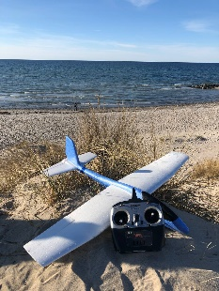
Lidl’s stocked their foamy gliders again earlier in the year, and there was a huge interest in converting these in various different forms by the EDRCC membership. There was even a Telegram group generated to enable ideas etc to be shared.
They are often now seen in their variants at Peak Hill and other souring sites. Steve has even bungeed his from the strip.

173
Well, this has become a non-event now, the new phoenix that Mike built to replace 173, has been a waste of time, Mike is happier trying to pretend he is in Star Wars, than seriously trying to get the best speed out of it. Josh and Rog, who were both in the running have also given up. I wait to see what Oscar and Tom can do when they get the speed bug.

Tossers

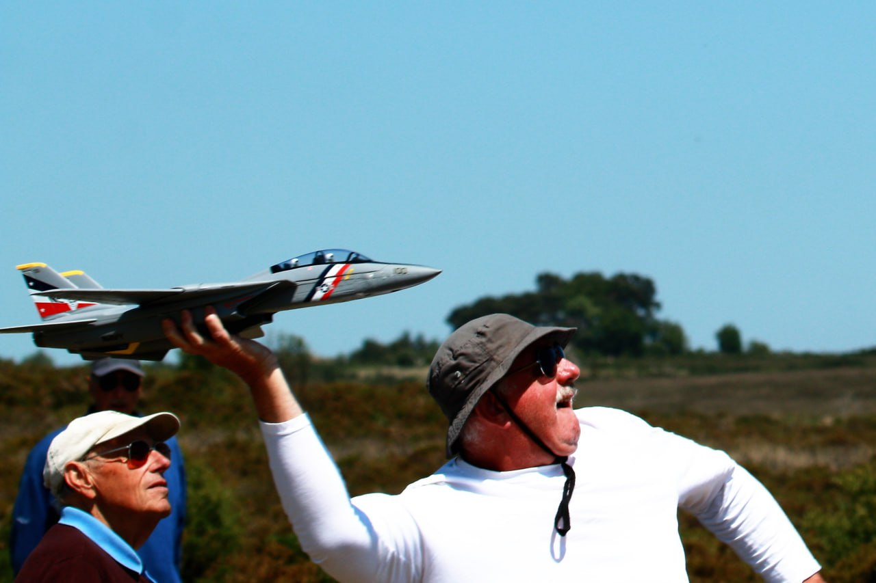

Nothing more to be said about this…………

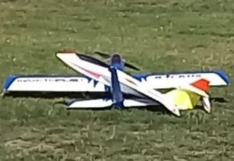
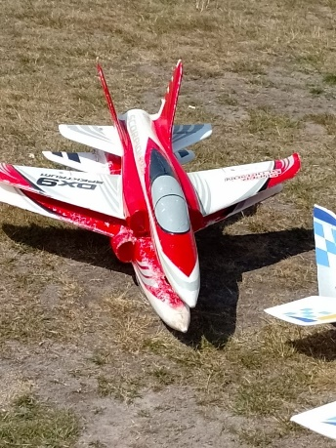
Perversions.

There are standards in clubs that should be upheld. Too much of this sort of thing just will not do…..

Committee.

Once again during the whole of 2023, the Committee has been working hard with the BMFA, the CAA, the CDE to ensure that we can all continue to enjoy the pleasures that out precious hobby brings…., There have been changes to the committee this year with our long time Chairman Felix stepping down from his role, and to be replaced by one of the most hard-working guys in our club Mike Jones. In order to fill Mike shoes as Secretary, Martin Brown has taken on the Job. Nigel has moved into Martin’s shoes. Finally, although Felix has resigned from his role as Chairman, he is still on the committee to help and pass on his wealthy of knowledge that he has gained over the years.

My final words are, what a wonderful year we have all had on our strip at Woodbury, IMHO this is one of the best clubs in the country. We all get on so well, and always so very helpful to each other.
Happy New year to you all, and a very prosperous and great flying year in 2024.

And as our Chairman would say… “May the force be with you”…
